15th June 2026
HAWLEY PRIMARY SCHOOL
KS1 VISIT TO THE WIZARD OF OZ AT CAMBERLEY THEATRE
WEDNESDAY 16TH DECEMBER 2026
Dear Parents

Whilst it is a long way off (192 days!) we have already booked our pantomime visit for 2026. This year, in light of historic issues with collections due late coaches caused by rush hour traffic, we spent some time investigating other options and have decided to visit a performance that takes place in the school day which will have no impact on drop off and collection times for parents.

So, to celebrate the festive season, the children in KS1 will be visiting Camberley Theatre, to see The Wizard of Oz on Wednesday 16th December 2026.

As the visit will take place during the school day the children will need to wear school uniform and school shoes and have a waterproof coat with them. They will not require any spending money. We will be travelling by coach, fully fitted with seat belts, and will be leaving school at 9.40am, returning to school at 1.00pm when the children will be taken to the school hall for lunch.

We would be grateful for a payment of £18.25 to cover the cost of the coaches and pantomime. You may make a payment for this activity using Arbor (Childs profile - Activities - Trips - all trips).

Your child will be provided with a small bag of sweets to eat during the interval. We will contact you nearer the time with further information and to check allergies.

We no longer require you to complete a permission slip for each visit as we will assume that in paying for your child to attend the visit you have provided your consent. We will use the contact numbers and medical details that we already have on file but would ask that you let us know should any of this information need updating prior to the visit taking place.

The deadline for payment is Friday 10th July as the venue need confirmation of numbers at the beginning of September. Children not attending the pantomime will be taught in school during these sessions.

Yours sincerely
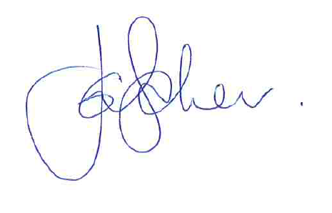
Jane Baker
Headteacher

